WEST POKOT COUNTY

COUNTY URBAN INSTITUTIONAL DEVELOPMENT STRATEGY (CUIDS) 2020-2021

FEBRUARY 2020
1: URBANIZATION, URBAN MANAGEMENT AND URBAN DEVELOPMENT IN THE COUNTY
1.1. Urbanization and Urban Development in West Pokot County
Key Urban Centres | 2009(Census) |  |  | 2017(Projected) |  |  | 2022(Projected) |  |  | 2030(Projected)
 | M | F | Total | M | F | Total | M | F | Total | M | F | Total
Kapenguria | 34,858 | 34,999 | 69,857 | 52,841 | 53,054 | 105,895 | 68,693 | 68,970 | 137,664 | 106,475 | 106,904 | 213,378
Chepareria | 12,589 | 12,918 | 25,507 | 19,083 | 19,582 | 38,666 | 24,808 | 25,457 | 50,265 | 38,452 | 39,458 | 77,910
Total | 47,447 | 47,917 | 95,364 | 71,924 | 72,637 | 144,561 | 93,501 | 94,427 | 187,928 | 144,927 | 146,362 | 291,288
West Pokot County has two major urban areas namely; Kapenguria and Chepareria as per the provisions of Section 9 and 10 of the Urban Areas and Cities Act, 2012.The two urban Centres are strategically placed in terms of connectivity along the Kitale- Lodwar A1road to other trading Centres in the county. Both Centres have social amenities such as health Centres, schools and entertainment joints. The table below shows the population projections by Urban Centres
Source:County Statistics Office (2018), Kapenguria

Currently, 18.6 percent of county residents in west Pokot County live in urban areas as per the 2009 census. This urban population is projected to grow by 30 percent and 55percent by 2022 and 2030 respectively. Majority of this urban population comprises of people aged between 15 to 64 years who are economically active.
1.1.1. County's Main Urban Areas
The main urban areas in West Pokot County are Kapenguria Municipality in West Pokot Sub-County and Chepareria Town in Pokot south Sub-County. Other Market Centres include:
Ortum,Kabichbich,Sigor,Lomut,Chesegon,Kacheliba,Orolwo,Sarmach,cheptuya,kanyarkw at,serewo,Kiwawa,Kamelei,Kasei,Tamkal,Nyangaita, orwa,Sina,Tapach,Kamketo,
Kachemogen, Kapsangar,Chepkono, Kaptabuk, kapsait, Chepkondol,Sebit, Kodich,
Konyao, and Alale.

1.1.2. Urbanization and County Socio-Economic Development
The main economic activities in the county urban areas include: retail and wholesale trading, fresh produce and cereals businesses, entertainment and hospitality businesses, service industries including motor garages, cyber cafes, law firms, livestock auctions, private education businesses, honey processing, banking and financial services, real estate enterprises and road transport services.

1.1.3. Role of Urban Areas in the County Economy
County urban areas play an important role in West Pokot County economic development. They provide ready markets for raw agricultural and livestock produce from the hinterlands, create employment to the county residents, provide revenues to county and national government, provide higher educational facilities and promotes national cohesion through community interactions and sharing of cultures, promotes infrastructure development and technological innovations and skills transfer.

1.1.4. Rural-Urban Linkages in the County
The county urban and rural areas are heavily interlinked. While urban areas provide market for agricultural and livestock produce from rural areas, rural areas provide raw materials, fresh food and building materials(Sand & timber) for urban residents. Urban areas provide jobs for rural residents. County revenues and remittances are used to empower people and develop infrastructure in rural areas. Other areas of interlinkage include facilitating economies of scale, transport and communication systems. These interlinkages create opportunities for increased employment and income generation.
1.1.5. Urban Development Challenges
County urban areas in West Pokot face a myriad of development challenges. West Pokot County urban areas lack county policy on urban planning and development control,County Urban Integrated Development Plan and local physical development plan. Most roads are not all weather with poor drainage system and consequently pose major transport challenge during rainy seasons. There is no designated solid waste dumpsite.The existing temporary dumpsite is poorly located since it is on a riparian area.The county also lacks liquid sewerage system. The urbanareas lack adequate health facilities,play grounds, tertiary institutions and housing. Poverty and unemployment levels are also high.
1.1.6. Basic urban services that are provided in the county urban areas
Services currently being offered in the county urban areas include; cleaning and refuse collection, provision of health services, construction of markets and livestock sale yards,street lighting, abattoirs, stadium, tarmacking of urban roads, ambulances, pre-primary education.
1.1.7. Urban Score Card
The urban management is unable to provide adequate services within its mandate due of inadequate financing, skills and competencies, inadequate infrastructure.
1.1.8. Urban Planning and Urban Land Use Management
There is an old urban plan of 1982 that has been overtaken by uncontrolled development, hence the need for re-planning. Most of the land use is for commercial,residential use and urban agriculture.
1.1.9. State of Housing in West Pokot Urban Areas
Most of the buildings in the urban areas hardly meet the required building standards and regulations. Currently, housing demand exceed the supply.
1.2. Legal and Regulatory Systems for Urban Management in West Pokot County
The national laws and regulations governing urban management includes: the urban areas & cities Act, 2012 and urban areas & cities (amendment) act 2019, Cap 286 of Physical planning Act, and County government act, 2012.At the county level, West Pokot County Urban Planning Act, 2016, West Pokot County Finance Act,2018 have been enacted.
1.3. County-Wide Planning and Urban Development
The implementation of County Integrated Development Plan for the period 2013-2017 came to an end on 31st December 2017.It identified policies, programmes and projects that required to be implemented under urban areas but were not implemented due to
budget constraints and institutional capacity gaps. These gaps include inadequate staff, weak institutional structure for urban development, staff capacity gaps, inadequate funding, poor leadership and governance challenges. Sectoral plans were not prepared during the plan period. In summary, urban areas needs and priorities were not adequately mainstreamed into previous county plans.
The County Integrated Development Plan (2018-2022) has been developed. It contains many strategic priorities, goals and objectives for implementation under urban areas for the period 2018-2022.The issues identified in this strategy document have been mainstreamed in the county plan. The plan has financial resources gap to ensure all its aspirations, goals, projects and programmes are fully implemented
1.4. Current status of urban areas in West Pokot County

Use Urban Area Institutional Development Matrix: Current Situation (see attachment 1).

2: DEVELOPING INSTITUTIONS FOR URBAN MANAGEMENT
2.1 Institutional Development for West Pokot County Urban Areas
The Kapenguria Municipality is already institutionalized with a charter in place. A Municipal Manager and Municipal Board are also in place. Town administration and Town committees for other urban areas has been budgeted for in the financial year 2019-20 and will be established before the end of the current financial year for the towns that meet the criteria as set out in the Urban Areas and Cities Act, 2012(amended 2019). The county government plans to confer town status to Chepareria, Kabichbich, Sigor ,Kacheliba, Ortum and Alale in the near future. Further, the county government has set up 6 town administrations and later the town committees for these urban Centres will be established soon.
2.1.1. General Relationship between West Pokot County Government and Urban Areas.
The Municipal Manager shall prepare a budget on behalf of the Board. The budget shall be presented before the board for scrutiny and adoption. The budget will be forwarded to the County Executive for adoption and integration to the County Budget. The budget will then be forwarded to the County Assembly for consideration.
Once the budget is approved, the Board administers its budget through the County Treasury in line with PFM Act, 2012.With the approval and authorization of the County Treasury, the board shall open and maintain recurrent and development accounts with the Central Bank of Kenya where its funds shall be maintained. The municipal manager shall be the accounting as provided under section 28, 29 and 30 of the urban areas &cities act, 2012.
Staffing for the urban areas will be done by County Public Service Board through competitive filling in line with the Urban Areas & cities Act, 2012 and County Government Act,2012
2.1.2. Accountability of the Urban Boards
The books of accounts are prepared by the accounting officer (Municipal Manager) on behalf of the board. The books are audited by the Auditor General who will then directly send a report to the County Assembly for consideration.
After the county assembly considers the audit report, it is taken back to the Board for implementation as provided for in section 43, 44,45,46,47 and 48 of urban areas and cities act, 2012 (amended 2019)
2.1.3.Joint/Collaborative Development and Service Delivery Improvement Initiatives
The board may enter into partnerships and joint ventures with other public or private entities to provide urban services and financing development projects and programmes. The urban areas management will also strengthen public participation on the delivery of its services and identification of development programmes, it will also introduce
balanced scorecard, rapid results initiative, results based management, participatory monitoring & evaluation and strengthen civic education.
The board shall establish and operationalize service delivery sectors/departments for efficient service provision. The board shall have a service charter and an organizational structure/ organogram to oversee service delivery as shown below:
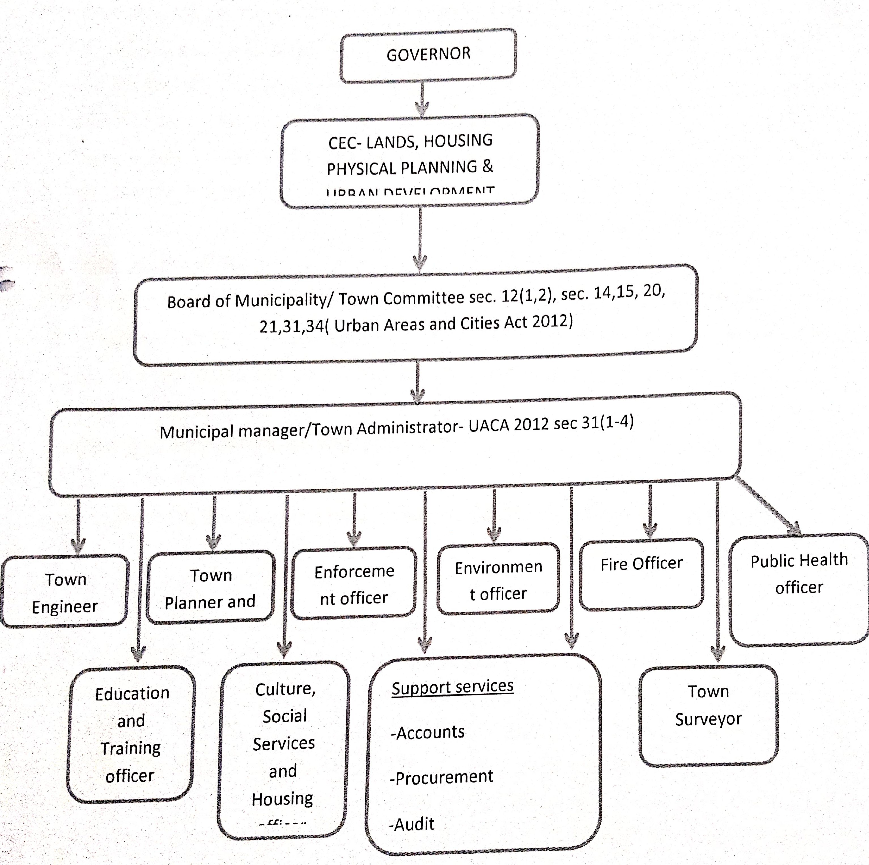
For each urban area in the county (use Urban Area Institutional Development Matrix, see attachment 2)
2.2 Legal and Regulatory Reforms at the County Level
In place we have West Pokot County Urban Planning Act 2016.Regulations to operationalize the law is yet to be developed. There is no county Urban Planning and Development Control Act yet. There are no by laws in place to support urban basic services delivery-i.e. solid waste management, pollution, traffic control etc
West Pokot Finance Bill governing revenue collection in the entire county is in place. There is also Valuation roll and Rating Act in use. There is no legislation on citizen engagement, and public participation

2.3Capacity building
The capacity building actions required to support changes in urban management are training of existing urban management staff and Board members. There is also need to strengthen civic education for citizenry living in urban areas.

3: ANNUAL ACTION PLAN AND BUDGET

The details for the annual action plan and budget are outlined in attachment 3

URBAN AREA INSTITUTIONAL DEVELOPMENT MATRIX: CURRENT SITUATION

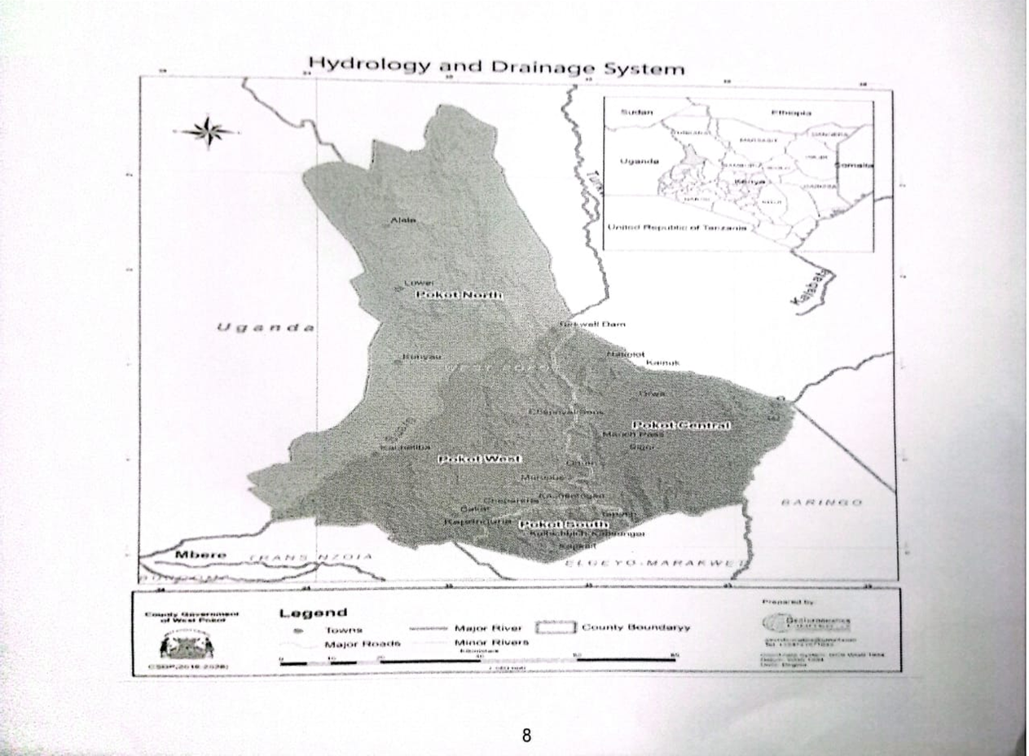
Name(s)of urban area | Geographical and demographic data |  |  | Institutional status |  | Urban management
 | Location | Est.popn. | County capital (Y/N) | Pre 2010 administrative status | Current  administrative  status and/or  current urban  management  arrangements | Board or Committee (Y/N) | Town or  Municipal or  city manager  or  administrator  (Y/N) | Office (Y/N) | Staffing of  municipality  or town  administration | Budget and finance | Urban planning | Infrastructure  and service  delivery  responsibilities
Kapenguria Municipality | Longitude (  34°47'  and 35°  49'East  and  latitude (1°  and 2°  North | Use  most  recent  official  data  (e.g.  census)  36,696 | Y-Kapenguria | Municipality | Municipality  with town  administration  and staff being  paid out of  municipal  budget vote | Y-municipal Board | Y-Municipality  has an  officially  designated  municipal  manager | Yes | -yes  If so,how  many  professional or  technical staff--  7 | Yes,  budget  vote of the  municipality  FY 2019-  20-Ksh  45,384,000. | Does the  urban area  have any  urban  plans? --no  If yes,what  plans  currently  exist and  when were  they  completed?  -IDeP  (date)  Spatial  (town)  plan  (date) | What are the  specific infra-  structure and  service delivery  responsibilities  of the urban  area board or  administration  or  administrator?  - Solid waste  Management  -Storm  drainage  Development  planning &  control  -Traffic control  Water &  sanitation  Street lighting  Outdoor  advertising  - Cemetery &  crematoria  - Fire fighting &  disaster  management  -Refuse  collection

·Local distributor roads
-Recreational parks& market
management
Chepareria Longitud  Kacheliba 340 47'  Alale and 350  Kabichbich 49'East  Ortum and  Sigor latitude(10  (Weiwei and 20  North | e( N | Cheparia-  town  council  Others-  county  councils | None | None | None | None | Chepareria-Y Others-N | None | None | None | - Solid waste  - management  - Storm  - drainage  - Development  - planning &controll  - Traffic control Water &  - sanitation Street lighting  - Outdoor advertising  - Cemetery &crematoria  - Fire fighting &disaster Management  - Refuse collection  - Local distributor roads  - Recreational parks& market management

ATTACHMENT 2
URBAN AREA INSTITUTIONAL DEVELOPMENT MATRIX-Proposals for 3 -5 year horizon
Name(s) of urban area | General |  | Specific
 | Current institutional arrangements | Planned institutional arrangements? | Board or  Committee Y/N  Timelines | Town or city manager or administrator Y/N  Timelines | Office Y/N Timelines | Staffing of  municipality or town  administration Numbers  Timelines | Budget and finance  Budget  status?  Timelines | Urban planning Timelines | Infrastructure and service  delivery  responsibilities Timelines | Demarcation of urban  area?  Y/N
Kapenguria Municipality | -Municipality Chartered | N | Municipal board | Municipal manager appointed | available | N  Additional  needed  No.  Civil  Engineer-1  Architect-1  Physical  planner-1 | N/A | Y  IDeP-Y  Spatial  plan-Y  By 30th  June 2020 | Y  -Solid waste  management  -Water and  sanitation  provision  -Drainage  management -Construction and  management of urban  roads  -Construction and  maintenance of  recreational parks and  green spaces -Street  lighting  -Traffic  control and parking  Outdoor  advertising  -Management  of municipal  markets and  abattoirs  -Fire stations  Deadline-By  30th March  2020 | N

ATTACHMENT 3
COUNTY URBAN AREA INSTITUTIONAL DEVELOPMENT-ANNUAL ACTION PLAN & BUDGET
County:_WEST POKOT_ FY:_2020-2021
CUIDP Section | Activity | Timeframe |  |  |  |  |  |  |  |  |  |  |  | Implementation modality | Cost elements | Proposed budget (KES)
 |  | J | A | S | O | N | D | J | F | M | A | M | J
Section 3:  Developing  institutions for  urban  management | Hold consultations with residents in urban areas |  |  |  |  |  |  |  | Y | Y |  |  |  | In-house county government staff to be used | Meeting costs  Per diems for  travel  Local travel costs | 150,000
 | Prepare investment project pipeline for urban areas |  |  |  |  |  |  |  |  |  | Y | Y |  | - External  consultants to be  hired  In-house county  government staff  to be used | Consultancy fees  Meeting costs  Per diems for  travel  Local travel costs  Office equipment | 2,100,000
 | Train urban management staff,CPCT, County Assembly & board on strategic management |  |  |  |  |  |  |  |  | Y | Y |  |  | - External  consultants to be  hired  - County  government staff  to be used | Consultancy fees  Meeting costs  Per diems for  travel  Local travel costs  Training materials | 2,977,581
 | Equipping municipal and urban offices |  |  |  |  |  |  |  |  |  |  |  |  | - |  | 1,500,000
 | Other Urban centers administration training and exposure trip |  |  |  |  |  |  |  |  |  |  |  |  | - | Meeting costs  Per diem costs for  travel  - Training materials | 2,229,938
 | TOTAL BUDGET |  |  |  |  |  |  |  |  |  |  |  |  | - | - Total annual UIG budget | 8,957,519

